1. What is Database?

A database is a structured collection of data that is organized in a way that allows for efficient storage, retrieval, and manipulation of information. In other words, it's a system or software application that stores and manages digital information in a way that allows users to easily access, update, and retrieve data. They can be used to store anything from customer information, sales data, inventory lists, and much more.

Some common types of databases include relational databases, NoSQL databases, object-oriented databases, and graph databases. Each type has its own unique characteristics and is designed for specific use cases.

There are many databases available like MySQL, Sybase, Oracle, MongoDB, Informix, PostgreSQL, SQL Server, etc.

Modern databases are managed by the database management system (DBMS).

SQL or Structured Query Language is used to operate on the data stored in a database. SQL depends on relational algebra and tuple relational calculus.

Relational databases: These are the most common type of databases and they organize data into tables with rows and columns. They use SQL (Structured Query Language) to manage and manipulate data. Relational databases are good for handling structured data with well-defined relationships between tables, such as customer data, order data, and inventory data.

NoSQL databases: NoSQL databases are designed for handling unstructured data that doesn't fit neatly into tables. They use a variety of data models, such as key-value stores, document databases, and graph databases, to store and manage data. NoSQL databases are good for handling large volumes of unstructured data, such as social media data, log data, and sensor data.

Object-oriented databases: These databases store data in objects, which are instances of classes in object-oriented programming. They are designed to handle complex data structures and are often used for software development, such as in web applications and mobile apps. Object-oriented databases are good for handling complex data structures, such as those found in software applications.

Graph databases: These databases are designed for managing relationships between data entities, such as social network connections or product recommendations. They use graph structures to store and manage data, and they are optimized for handling complex queries that involve traversing relationships between entities. Graph databases are good for handling data with complex relationships, such as social networks and recommendation systems.

1. What is Data Warehouse

A data warehouse is a large, centralized repository of data that is used to support business decision-making. It is designed to store data from a variety of sources, such as transactional databases, operational systems, and external data sources, and to transform that data into a format that is optimized for querying and analysis.

Data warehouses are often used in business intelligence (BI) applications to provide insights into business operations and performance. They typically use a relational database structure, with tables organized into dimensions and fact tables. Dimension tables provide descriptive information about business entities, such as customers or products, and fact tables provide quantitative data, such as sales or inventory levels.

The data in a data warehouse is often historical, meaning that it represents a snapshot of business operations at a particular point in time. This allows users to analyze trends and patterns over time and to make informed decisions based on historical data.

Data warehouses can be very large and complex, and they require specialized tools and techniques for managing and analyzing the data. Some common tools used in data warehousing include ETL (extract, transform, load) tools for moving data from source systems to the data warehouse, data modeling tools for designing the database schema, and BI tools for querying and analyzing the data.

1. Need of DWH

There are several reasons why a business might need a data warehouse (DWH):

**Centralized data storage:** A DWH provides a centralized location for storing data from different sources, such as transactional databases, operational systems, and external data sources. This makes it easier to manage and maintain data, and ensures that analysts have access to a single, consistent version of the data.

**Data integration:** A DWH is designed to integrate data from disparate sources, which can help to eliminate data silos and ensure that users have a complete view of the data. This can help to identify insights and relationships that may not be apparent when looking at individual data sources.

**Historical analysis:** A DWH typically stores historical data, which can be used for trend analysis, forecasting, and other types of historical analysis. This can help to identify patterns and trends over time, and to make informed decisions based on historical data.

**Scalability:** A DWH is designed to handle large volumes of data, which makes it well-suited for businesses that generate a lot of data. As the business grows and generates more data, the DWH can be scaled to accommodate the additional data.

**Business intelligence:** A DWH is often used as a data source for business intelligence (BI) applications, such as dashboards and reports. BI tools allow users to analyze and visualize data from the DWH, which can help to identify trends, patterns, and insights that can inform business decisions.

**Data organization:** A DWH organizes data in a way that makes it easy to retrieve and analyze. This can include organizing data into dimensional models or using other data modeling techniques that make it easy to identify relationships and patterns in the data.Data warehouse helps you to reduce TAT (total turnaround time) for analysis and reporting.

**Reduced contention:** Transactional databases are designed to optimize transactional processing, such as inserting, updating, and deleting data. When analytical queries are executed against the same database, they can contend with transactional processing, leading to performance degradation. By separating analytics processing into a separate system, contention is reduced, and both systems can perform optimally.

**Data Quality Checks:** When stakeholders and users rely on data from source systems without proper data quality assurance, there is a risk of overestimating the quality of the data.

A DWH can include data quality checks as part of its ETL (Extract, Transform, Load) process. These checks can identify and flag data quality issues such as missing or inconsistent data, outliers, and data formatting errors. This helps ensure that the data in the DWH is accurate and reliable, which in turn leads to more accurate reports.

1. Characteristics of DWH
2. Subject-oriented – A data warehouse is always subject oriented as it delivers information about a theme instead of organization’s current operations. It can be achieved on a specific theme. That means the data warehousing process is proposed to handle a specific theme which is more defined. These themes can be sales, distributions, marketing etc.

A data warehouse never puts emphasis only on current operations. Instead, it focuses on demonstrating and analysis of data to make various decisions. It also delivers an easy and precise demonstration around a particular theme by eliminating data which is not required to make the decisions.

1. Integrated – A data warehouse integrates various heterogeneous data sources like RDBMS, flat files, and online transaction records.

Data is stored as a single unit , not as a collection of files that may have different structures or organizations

It requires performing data cleaning and integration during data warehousing to ensure consistency in naming conventions, attributes types, etc., among different data sources. Integration means finding a shared entity to scale all similar data from the different databases.

Integration of data warehouse benefits in effective analysis of data. Reliability in naming conventions, column scaling, encoding structure etc. should be confirmed.

1. Time-Variant –   
   Historical information is kept in a data warehouse. For example, one can retrieve files from 3 months, 6 months, 12 months, or even previous data from a data warehouse. This is different with a transactions system, where often only the most current file is kept.

In this, data is maintained via different intervals of time such as weekly, monthly, or annually etc. It finds various time limits which are structured between the large datasets and are held in an online transaction process (OLTP). The time limits for data warehouses are wider-range than that of operational systems. The data residing in the data warehouse is predictable with a specific interval of time and delivers information from the historical perspective. It comprises elements of time explicitly or implicitly. Another feature of time-variance is that once data is stored in the data warehouse then it cannot be modified, altered, or updated. Data is stored with a time dimension, allowing for analysis of data over time.

1. Non-Volatile – As the name defines the data resided in the data warehouse is permanent. It also means that data is not erased or deleted when new data is inserted. It includes the mammoth quantity of data that is inserted into modification between the selected quantity on logical business. It evaluates the analysis within the technologies of the warehouse. Data is not updated, once it is stored in the data warehouse, to maintain the historical data.

In this, data is read-only and refreshed at particular intervals. This is beneficial in analyzing historical data and in comprehending the functionality. Functionalities such as delete, update, and insert that are done in an operational application are lost in the data warehouse environment.

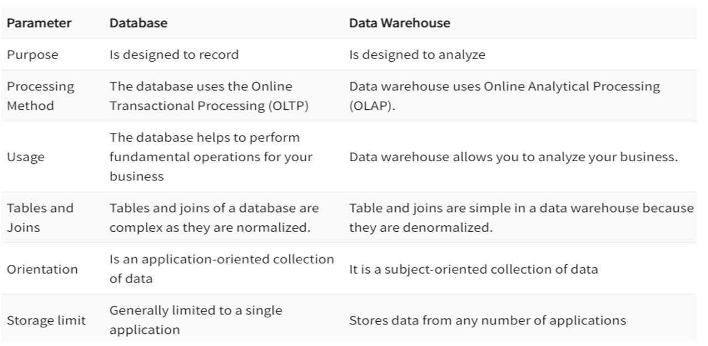

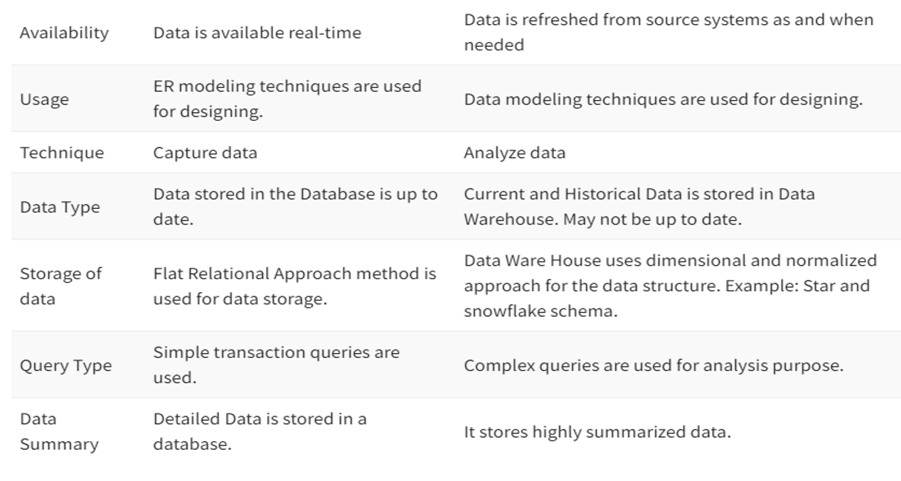

APPLICATIONS OF DWH:

E-commerce: E-commerce platforms need to gather key marketing metrics (such as clicks, impressions, website visitors, etc.) from marketing tools and use that to approach their customers in a better way. This is where data warehouses help. Replicating data, tracking & visualizing KPIs such as conversion rates, churn rates, and return on ad spends, safe storage, etc. help companies perform better. In recent times, amazon redshift is the most popular warehouse being used for marketing analytics, because of its user-friendly UI and flexibility.

Retail: Data warehouses can be used by retailers to easily identify products with high demand and the fastest selling demand. The data can then be used to react to a rise or fall in consumer demand quickly, which can ultimately be used to gain a competitive advantage. Reverse ETL is a popular concept that leverages data from warehouses and helps target audiences better. They are the mediators between wholesalers and end customers, and that’s why it is necessary for them to maintain the records of both parties. For helping them store data in an organized manner, the application of data warehousing comes into the frame.

AI/ML: With many companies embracing AI for their data journey, it’s critical to get a reliable data warehouse now. AI enables data maturity, which is intertwined with the flexibility, scalability, and agility that a warehouse offers. On the other hand, machine learning is used on the data after the data has been replicated and transformed in the warehouse, to help newer business models emerge and advance digital disruption.

Agritech: Data storage is a must when it comes to the new age of farming. Data related to crop yield, weather conditions, pesticides, crop inventory and so much more demands a data warehouse. With advanced analytics, engineers and business analysts are able to figure out inefficiencies in the ecosystem, such as problems in the soil quality, unnecessary use of pesticides, etc. and iron them out.

Sustainability and climate action: Climate data requires a versatile data infrastructure, with cloud-first models for warehouses. To bring out sustainability insights, the data architecture must be able to integrate raw data from multiple sources and make it easy for end-users for making predictions and effective decisions related to climate change.

Manufacturing & Supply chain: Being one of the industries involving a higher number of intermediaries, the supply chain industry needs data warehouses to limit the number of data silos and ultimately human error. Data warehouses can help in inventory management (which items are low in count and what is the cost of each step in the life cycle), all the data related to vendors, logistics (for example: timestamp data related to product delivery), and ultimately serving the customer better.

Healthcare: With constant advancement in healthcare, the data captured by machines is huge. To digitally improve hospital infrastructure, reduce wait time, and make processes more efficient, data warehouses are making data work constantly in this field. Getting personalized healthcare can be possible with a single platform (such as having one place for all diagnostics, tests, prescriptions, and follow-ups). All the clinical, financial, and employee data are stored in the warehouse, and analysis is run to derive valuable insights to strategize resources in the best way possible.

Banking & Finance: Data security is critical for the BFSI sector, and data warehouses solve that problem by vouching for industry-standard security compliances. The warehouses can be used to get updates about customer deposits, loans, funds, deposits, etc., and a better understanding of the performance of different branches. The right solution helps the financing industry analyze customer expenses that enable them to outline better strategies to maximize profits at both ends.

Financial Auditing: With access to real-time financial data, warehouses ensure decisions related to the business’s current financial performance can be reached quickly. Data warehouses enable the collection of data on a daily basis and information can then be regularly used to identify any discrepancies in financial reporting & audits.

Pharmaceuticals: As data warehouses make data more accessible, it’s now being used for making better strategic decisions and identifying & developing customer buying trends in pharmaceuticals. This results in better customer targeting, pre-call analysis as well as post-call assessments, helping the pharma industry at scale.

FUNCTIONS OF DWH:

Data Integration: One of the primary functions of a DWH is to integrate data from various sources, such as transactional systems, operational databases, and external data sources. This integration process ensures that data is accurate, consistent, and reliable, which improves the quality of BI reporting and analysis.

Data Transformation: Data in a DWH is transformed into a format that is optimized for BI reporting and analysis. This includes aggregating and summarizing data, creating calculated fields, and transforming data into a standardized format.

Data Storage: A DWH is designed to store large amounts of data over an extended period. This data is typically historical data, which is used for trend analysis, forecasting, and identifying patterns over time.

Query and Reporting: A DWH enables users to query and retrieve data using various tools and techniques, such as SQL, OLAP (Online Analytical Processing), and data mining. Reports can be generated in various formats, such as dashboards, charts, and graphs.

Data Security: A DWH provides various security measures to protect data from unauthorized access, such as role-based access control, encryption, and auditing. This ensures that data is secure and that privacy regulations are being adhered to.

Performance Optimization: A DWH is optimized for BI reporting and analysis, which requires fast query response times and high throughput. Various techniques can be used to optimize performance, such as indexing, partitioning, and caching.

Metadata Management: A DWH contains metadata, which describes the structure, relationships, and characteristics of the data. Metadata management ensures that the metadata is accurate and up-to-date, which is critical for effective BI reporting and analysis.

DATA MINING

Data mining is the process of discovering patterns, trends, and insights in large datasets through the use of statistical and machine learning techniques. It involves exploring and analyzing large datasets to uncover hidden patterns, correlations, and relationships that can be used to make informed decisions.

The data mining process typically involves several steps, including data preparation, data exploration, model building, and model validation. During the data preparation phase, data is collected from various sources and cleaned, transformed, and formatted to be ready for analysis. In the data exploration phase, the data is analyzed to identify patterns and relationships.

Once the patterns and relationships are identified, data mining algorithms are used to build predictive models that can be used to make predictions about future events or behaviors. Model validation is then performed to ensure that the model is accurate and reliable.

Data mining is used in a wide range of applications, including fraud detection, market analysis, customer segmentation, recommendation systems, and risk management. It is often used in conjunction with other data analysis techniques, such as data warehousing, business intelligence, and data visualization, to provide a more comprehensive understanding of the data.

For example, banks typically use ‘data mining’ to find out their prospective customers who could be interested in credit cards, personal loans, or insurance as well.

Since banks have the transaction details and detailed profiles of their customers, they analyze all this data and try to find patterns that help them predict that certain customers could be interested in personal loans, etc.

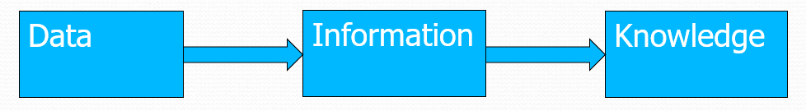

Data: Data refers to raw, unorganized, and unprocessed facts, figures, and symbols that have no meaning on their own because of lack of context and interpretation. Data can be in the form of numbers, text, images, or other types of digital or analog signals.

Information: Information is derived from data through the process of organizing, structuring, and interpreting it in a meaningful way. Information provides context and meaning to data and is useful for making decisions and taking actions. It is data endowed with meaning and purpose. For example, a list of sales figures by region is just data, but when that data is organized and presented as a chart or graph, it becomes information that can be used to analyze sales trends and make business decisions.

Knowledge: Knowledge is derived from information through the process of analyzing and synthesizing it to gain insights and understanding. Knowledge represents a deeper level of understanding that enables individuals to apply information to specific situations and contexts. For example, a sales manager who has knowledge about customer behavior and market trends can use that knowledge to make informed decisions about sales strategies and product offerings.

types of patterns that can be mined in data mining:

Association rules: Association rules are used to discover interesting relationships between variables in large datasets. They involve identifying which variables tend to co-occur in transactions or events, and how frequently they appear together. For example, in a grocery store dataset, an association rule might be that customers who buy bread are more likely to buy butter.

Classification rules: Classification rules are used to predict the class of an object or event based on its attributes. This type of pattern mining is commonly used in supervised learning, where the algorithm is trained on a labeled dataset and then used to classify new instances. For example, a classification rule might predict whether a customer is likely to purchase a product based on their age, gender, and purchasing history.

Clustering: Clustering involves grouping similar objects or events together based on their attributes. This type of pattern mining is used to identify patterns in unlabeled datasets, and can be used for tasks such as customer segmentation or anomaly detection. For example, in a dataset of customer purchasing behavior, clustering might be used to group customers who have similar buying habits.

Sequential patterns: Sequential patterns are used to identify patterns that occur over time, such as sequences of events or actions. This type of pattern mining is commonly used in applications such as web log analysis, where patterns of user behavior can be used to improve website design or detect fraudulent activity. For example, a sequential pattern might be that customers who view a product page are more likely to make a purchase if they also view the product reviews.

Regression: Regression is used to identify relationships between variables and predict a continuous target variable. This type of pattern mining is commonly used in supervised learning, where the algorithm is trained on a labeled dataset and then used to predict the value of a target variable for new instances. For example, regression might be used to predict the price of a house based on its size, location, and other features.

Anomaly or Outlier Detection: Anomaly detection involves identifying data instances that do not conform to expected patterns of behavior. For example, in a credit card transaction dataset, an anomaly detection algorithm might flag transactions that are significantly different from a customer's typical spending behavior. Anomaly detection can be used to identify fraud or to detect unusual events in a dataset.

Stages of data mining process

Data Mining Process is classified into two stages: Data preparation or data preprocessing and data mining

Data Preparation involves data cleaning, integration, reduction, and transformation, while the mining part does data mining, pattern evaluation, and knowledge representation of data.

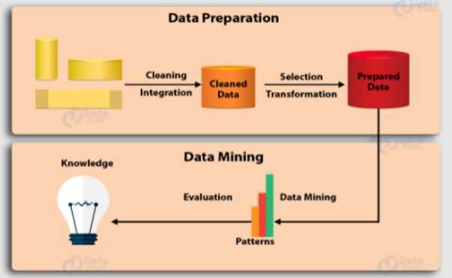

1. **Data Cleaning**

The first and foremost step in data mining is the cleaning of data. It holds importance as dirty data can confuse procedures and produce inaccurate results if used directly in mining. This step helps remove noisy or incomplete data from the data collection. Some methods can clean data themselves, but they are not robust. Data Cleaning carries out its work through the following steps:

(i) Filling The Missing Data: The missing data can be filled by various methods such as filling the missing data manually, using the measure of central tendency, median, ignoring the tuple, or filling in the most probable value.

(ii) Remove The Noisy Data: Random error is called noisy data. This noise can be removed by the method of binning.

Binning methods are applied by sorting all the values to bins or buckets. Binning is carried out by smoothing of bin, i.e., each bin is replaced by the mean of the bin.

Smoothing by a median, a bin median replaces each bin value. Smoothing by bin boundaries, i.e., the bin's minimum and maximum values are bin boundaries, and the closest boundary value replaces each bin value.

Then, identifying the outliers and solving inconsistencies.

1. **Data Integration**

When multiple data sources are combined for analysis, such as databases, data cubes, or files, this process is called data integration. This enhances the accuracy and speed of the mining process. There are different naming conventions of variables for different databases, causing redundancies. These redundancies and inconsistencies can be removed by further data cleaning without affecting the reliability of the data. Data Integration is performed using migration Tools such as Oracle Data Service Integrator and Microsoft SQL.

1. **Data Reduction**

This technique helps obtain only the relevant data for analysis from data collection. The volume of the representation is much smaller while maintaining integrity. Data Reduction is performed using Naive Bayes, Decision Trees, Neural networks, etc. Some strategies for the reduction of data are:

Decreasing the number of attributes in the dataset(Dimensionality Reduction)

Replacing the original data volume with more minor forms of data representation(Numerosity Reduction)

The compressed representation of the original data(Data Compression).

1. **Data Transformation**

Data Transformation is a process that involves transforming the data into a form suitable for the mining process. The quality and accuracy of the transformation process can have a significant impact on the quality and accuracy of the results obtained from data mining algorithms.

Strategies for data transformation are:

Smoothing: Data smoothing is executed by making use of a specialized algorithm for removing noise from the given data set. The given process is known to allow the important patterns of data to stand out. Data smoothing can help in predicting trends –like the ones found in security prices. Smoothing is a data transformation technique used to remove noise or irregularities from the data by replacing individual data points with a smoothed average. This technique is particularly useful for time-series data, where there may be random fluctuations or outliers that obscure underlying patterns or trends.

There are several methods for data smoothing that can be implemented effectively. Some of the common methods are known to include Moving Average, random walk, random method, seasonal exponential smoothing.

Aggregation: Aggregation is the process of summarizing or grouping data based on certain criteria. This may involve calculating averages, totals, or other statistics for each group or subset of data. Aggregation is useful for reducing the size of the data and making it easier to analyze. For example, in a customer database, data can be aggregated by location or age group to understand the behavior of different customer segments.

Normalization: Normalization is the process of scaling the data to a common range or distribution to eliminate the effects of differences in scale or magnitude. This helps to ensure that different variables are treated equally by data mining algorithms. Normalization is important because many data mining algorithms are sensitive to the scale of the data. Common normalization techniques include min-max scaling, z-score scaling, and decimal scaling.

Discretization: Discretization is the process of transforming continuous data into discrete values or categories. This is useful when analyzing data that has a large number of possible values or ranges, as it simplifies the data and makes it easier to analyze. Discretization can be done in various ways, including equal width binning, equal frequency binning, and clustering-based binning. For example, continuous age data can be discretized into age groups such as "18-25", "26-35", "36-45", and so on.

Generalization:  
It converts low-level data attributes to high-level data attributes using concept hierarchy. For Example Age initially in Numerical form (22, 25) is converted into categorical value (young, old).

For example, Categorical attributes, such as house addresses, may be generalized to higher-level definitions, such as town or country.

1. **Data Mining**

Data mining is the process of discovering patterns, trends, and insights in large datasets through the use of statistical and machine learning techniques. It involves exploring and analyzing large datasets to uncover hidden patterns, correlations, and relationships that can be used to make informed decisions.

The data mining process typically involves several steps, including data preparation, data exploration, model building, and model validation.

The data is represented in patterns, and models. Mining includes several tasks such as classification, prediction, clustering, time series analysis and so on.

1. **Pattern Evaluation**

Pattern Evaluation is the process that involves identifying interesting patterns representing the knowledge based on some measures. A pattern is considered to be interesting if it is potentially useful. Data summarization and visualization methods make the data understandable to the user.

1. **Knowledge Representation**

We have to represent data to the user in an appealing way. Knowledge representation is a critical component of data mining that involves capturing and encoding knowledge in a format that can be used by a computer system. Knowledge representation is necessary because the raw data that is analyzed in data mining is typically too complex and unstructured to be used directly by machine learning algorithms or other data mining techniques. By representing the data in a structured format, knowledge representation enables the development of models and algorithms that can be used to analyze and extract meaningful insights from the data.

APPLICATIONS OF DATA MINING:

Marketing and advertising: Data mining is widely used in marketing and advertising to identify customer segments, analyze customer behavior, and target marketing campaigns to specific audiences. By analyzing customer data, businesses can gain insights into customer preferences, purchase patterns, and other factors that influence buying behavior.

Fraud detection: Data mining is used extensively in fraud detection to identify patterns and anomalies in financial transactions that may indicate fraudulent activity. By analyzing large volumes of transactional data, fraud detection algorithms can identify suspicious patterns and alert authorities to potential fraud.

Healthcare: Data mining is used in healthcare to analyze patient data and identify patterns that can help doctors and other healthcare professionals make more informed treatment decisions. By analyzing large volumes of patient data, data mining can help identify risk factors for certain diseases, predict treatment outcomes, and identify opportunities for preventive care.

Manufacturing and supply chain management: Data mining is used in manufacturing and supply chain management to optimize production processes, identify bottlenecks in the supply chain, and forecast demand for products. By analyzing large volumes of production and supply chain data, businesses can identify opportunities for process improvement, reduce waste, and improve efficiency.

Sports analytics: Data mining is used extensively in sports analytics to analyze player performance, identify patterns in game data, and develop winning strategies. By analyzing large volumes of game data, sports teams can gain insights into player performance, identify weaknesses in their opponents, and develop game plans that give them a competitive advantage.

Financial analysis: Data mining is used in financial analysis to analyze financial data and identify patterns and trends that can help investors make informed investment decisions. By analyzing large volumes of financial data, data mining algorithms can identify patterns in stock prices, predict future market trends, and identify opportunities for investment.

Customer relationship management: Data mining is used in customer relationship management to analyze customer data and develop strategies for improving customer loyalty and retention. By analyzing customer data, businesses can identify factors that contribute to customer satisfaction, predict customer behavior, and develop targeted marketing campaigns to retain and attract customers.

Education: Data mining is used in education to analyze student data and identify factors that contribute to student success. By analyzing large volumes of student data, educators can identify patterns in student performance, identify areas where students may need additional support, and develop personalized learning plans to improve student outcomes.

Transportation: Data mining is used in transportation to analyze traffic patterns and optimize transportation routes. By analyzing traffic data, transportation companies can identify bottlenecks in the transportation network, optimize routes to reduce travel time and fuel costs, and improve overall efficiency.

Social media analysis: Data mining is used in social media analysis to analyze social media data and identify patterns in social media activity. By analyzing social media data, businesses can identify trends in customer behavior, identify opportunities for engagement, and develop targeted marketing campaigns to reach specific audiences.

TECHNOLOGIES USED IN DATA MINING:

Data mining involves the use of several technologies, tools, and techniques to analyze data and discover useful insights. Some of the commonly used technologies in data mining are:

Machine learning: Machine learning algorithms are used to train models on historical data, which can then be used to make predictions and identify patterns in new data.

Artificial intelligence: AI techniques such as neural networks and decision trees are used to analyze data and identify patterns.

Big data: Big data technologies such as Hadoop and Spark are used to process and analyze large volumes of data.

Cloud computing: Cloud platforms such as AWS, Azure, and Google Cloud provide scalable and cost-effective infrastructure for data mining.

Data warehousing: Data warehouses are used to store and manage large volumes of data for analysis and reporting.

Business intelligence: Business intelligence tools are used to visualize and report data insights to stakeholders.

Natural language processing: NLP techniques are used to analyze unstructured data such as text and speech.

Data visualization: Data visualization tools such as Tableau and PowerBI are used to create visual representations of data for easier interpretation and analysis.

Predictive analytics: Predictive analytics techniques such as regression analysis and time series forecasting are used to make predictions based on historical data.

Data preprocessing: Data preprocessing tools and techniques are used to clean, transform, and prepare data for analysis.

Sure, here is a brief explanation of each technology used in data mining:

Machine Learning: Machine learning is a type of artificial intelligence (AI) that involves training machines to learn from data, identify patterns, and make predictions or decisions without being explicitly programmed. It is used in data mining to build models that can identify patterns in large datasets and make predictions based on those patterns. Some popular machine learning algorithms used in data mining include decision trees, random forests, neural networks, and support vector machines.

It has a main research area that focuses on computer programs that will automatically learn based on the given input data and make intelligent decisions. There are similarities and interrelations between machine learning and data mining. For classification and clustering approaches, machine learning is often applied to predict accuracy. Typical machine learning problems that are utilized in mining are:

Supervised learning that makes use of class labels to predict information

Unsupervised learning doesn’t use class labels similar to clustering but it will discover new classes within data.

Semi-supervised learning will redefine the boundaries between two classes and makes use of both labeled and unlabeled examples.

Active learning will ask the user to label the classes that may be from unlabeled examples. It will optimize learning by acquiring data from the user.

Information Retrieval:

The technique searches for the information in the document, which may be in text, multimedia, or residing on the Web. It has two main characteristics:

Searched data is unstructured

Queries are formed by keywords that don’t have complex structures.

The most widely used information retrieval approach is the probabilistic model. Information retrieval combined with data mining techniques is used for finding out any relevant topic in the document or web.

Uses: A large amount of data are available and streamed in the web, both text and multimedia due to the fast growth of digitalization including the government sector, health care, and many others. The search and analysis have raised many challenges and hence Information Retrieval becomes increasingly important.

Statistics:

Data mining has an inherent connection with statistics. It studies the collection, and interpretation performs the analysis and helps visualize data presentation. A statistical model is used for data classes and data modeling. It describes the behavior of an object in a class and its probability. Statistical models are the outcomes of data mining tasks like classification and data characterization. Or we can use the mining task on top of the statistical models.

Database System & Data warehouse:

Database systems are used in query languages, query processing, optimization, and data models. Recent database system data analytics capabilities that use data mining and warehousing techniques. Data warehousing combines data from multiple sources (heterogeneous) and gathers historical data in various timeframes. It facilitates data cubes in a multidimensional database. The OLAP facilitates a multi-dimensional database. The data mining task is used to extend the existing requirement of the database system that would enhance the capabilities and enhance users’ sophisticated requirements

.

Big data: Big data technologies such as Hadoop and Spark are used to process and analyze large volumes of data.

Cloud computing: Cloud platforms such as AWS, Azure, and Google Cloud provide scalable and cost-effective infrastructure for data mining.

Business intelligence: Business intelligence tools are used to visualize and report data insights to stakeholders.

Natural language processing: NLP techniques are used to analyze unstructured data such as text and speech.

Data visualization: Data visualization tools such as Tableau and PowerBI are used to create visual representations of data for easier interpretation and analysis.

Predictive analytics: Predictive analytics techniques such as regression analysis and time series forecasting are used to make predictions based on historical data.

Data preprocessing: Data preprocessing tools and techniques are used to clean, transform, and prepare data for analysis.

Artificial Neural Networks: Artificial neural networks (ANN) are a type of machine learning algorithm that is designed to simulate the structure and function of the human brain. ANNs consist of interconnected nodes, or neurons, that process and transmit information. They can be trained to recognize patterns in data, classify data, or make predictions. ANNs are often used in data mining applications that involve image or speech recognition, natural language processing, and predictive modeling.

Genetic Algorithms: Genetic algorithms are a type of optimization algorithm inspired by the process of natural selection. They involve creating a population of potential solutions, evaluating the fitness of each solution, and using selection, mutation, and crossover operations to generate new solutions. Genetic algorithms can be used in data mining to optimize the parameters of machine learning models or to search for patterns in large datasets.

Decision Trees: Decision trees are a type of machine learning algorithm that are used for classification and prediction. They consist of a tree-like structure in which each node represents a decision or a test on a specific attribute, and each branch represents the outcome of the decision or test. Decision trees are often used in data mining applications that involve categorical or discrete data.

Rule-based Systems: Rule-based systems are a type of artificial intelligence that use a set of rules to make decisions or predictions. They consist of a set of if-then statements that define the conditions under which certain actions should be taken. Rule-based systems are often used in data mining applications that involve expert systems, fraud detection, or risk assessment.

Clustering: Clustering is a technique used in data mining to group similar objects together. It involves partitioning a dataset into subsets, or clusters, based on the similarity of the objects in each subset. Clustering can be used to identify patterns in data, segment customers or products, or detect anomalies in a dataset.

Association Rule Mining: Association rule mining is a technique used in data mining to identify patterns in large datasets. It involves discovering relationships between variables, such as frequent itemsets, and generating association rules that describe these relationships. Association rule mining is often used in market basket analysis, where it is used to identify products that are frequently purchased together.

These are just a few of the technologies used in data mining. There are many other techniques and algorithms that can be used to identify patterns and relationships in large datasets.